2018 Tax Year Updates
- Tax Tables
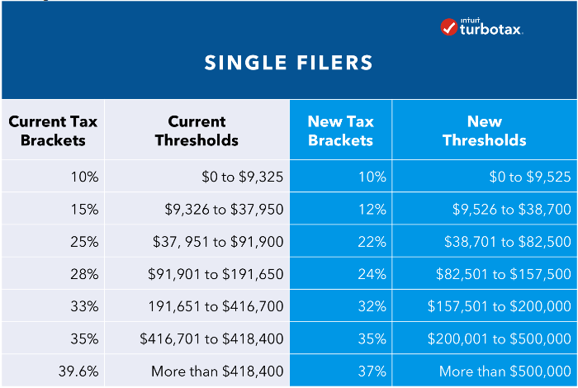
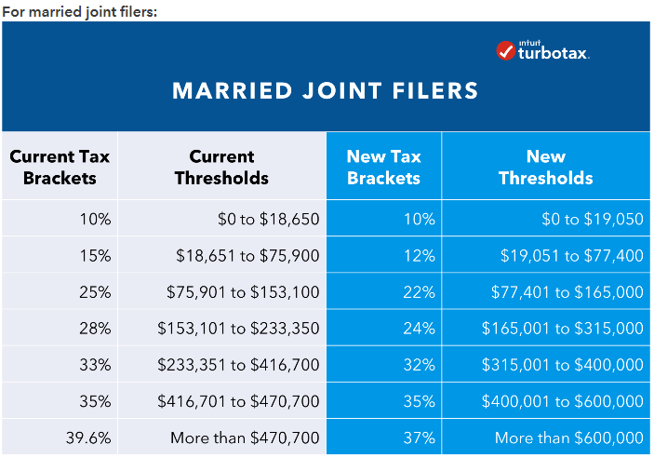
Standard Deduction:
2017 Deduction 2018 Deduction
Single -6,350 Single – 12,000
Married (Jointly) – 12,700 Married (Jointly) – 24,000
Child Tax Credit:
- Threshold raised from 110,00 to 400,000
- Child Tax credit raised from 1,000 to 2,000 per eligible child
Deductions Update:
- Personal exemptions are eliminated (loss of 4,050 per person)
- State, local property, income & sales tax cap at 10,000
- Mortgage Interest deduction capped at 750,000 for new home owners (Prior home purchases are grandfathered in)
- Eliminates non-insured tax penalty
- Lowers the threshold out-of-pocket medical expenses deduction to 7.5%; you can deduct medical expenses in excessive of 7.5% of your AGI instead of 2017’s 10% requirement.
Small Business Owners Updates:
- 20% deduction for qualified business income (small business owner deductions) Income Threshold (Single – 157,500/Married Jointly – 315,000)
- Eliminates corp. AMT
- Estate Tax Exclusion amount increased to 11.9M for individuals and 22.36 for married couple
- Gift Tax Exclusion amount increased to 15,000
- Bonus Depreciation deduction increased to 100% for assets

